Sprint 1 Plan

SlugIn

Aashna Shimkhada, Christina Chan, Erika Wu, Jetha Mot, Sara Srivastava, Sharon Akkara
Sprint Completion Date: End of Week 4 (10/24)
Revision 2: October 19th, 2025
Goal: Complete authentication & profile setup features so students can enter the platform and save opportunities. Ensure our users are UCSC students.
Task listing, organized by user story:
User Story 1.1 (“As a student, I want to make a profile so others can view my interests and reach out if needed.”) (9 points) [Aashna Shimkhada and Christina Chan]
- Task 1.1: Create a /profile page path (127.0.0.1:8080/profile) (1)
- Task 1.2: Add a box for user input (2)
  - Preferred Name, Last name, pronouns, email, Bio (optional)
- Task 1.3: Add a dropdown for user to choose (3)
  - Interested Industry, Majors/Minors, year in college
  - Make sure each dropdown lists all available choices
- Task 1.4: Add a button to save profile (3)
  - On button click, capture the user input and selection and execute a backend call
    - If any data has changed, update the user information

User Story 1.2 (“As a student, I want to have user authentication so that I can keep up with the applications I marked as applied for or saved.”) (12 points) [ Sara, Sharon, and Jetha ]
- Task 2.1: Create a /login, /signup page path (127.0.0.1:8080/signup, 127.0.0.1:8080/login) (1)
- Task 2.2: Add a box element for both pages (1)
- Task 2.3: Add fields for user input (2)
  - Login page: email, password
  - Signup page: email, username, password, password
    - Sanity check password and check that password has requirements (minimum length,
- Task 2.4: Add button to login/signup (4)
  - On button click, capture user input and execute backend call
    - Validate user exists or doesn’t exist
      - Login page:
        - If user exists, direct to app’s homepage
        - If user doesn’t exist, re-direct to signup page
      - Signup page:
        - If user exists, re-direct to login page
        - If user doesn’t exist, add user and prompt them to check inbox for verification email to access their account
- Task 2.5: New user verification (4)
  - Configure email templates in Supabase dashboard with app’s URL
  - Execute backend call on signup to send verification link to user’s email

User Story 1.3 (“As a faculty member or student club, I want to make a profile so that I can post opportunities.”) (5 points) [Erika]
- Task 1: Developing faculty/student-leader signup functionality (5)
- Task 1.1: Create a /login, /signupfaculty page path (1)
- Task 1.2: Add a box for user input (2)
  - Login page: email, password
  - Signup: email, username, password, password, faculty website(?)/option for student leader
    - Sanity check password and check that password is minimum X
- Task 1.3: add button to login and signup (2)
  - On button click, capture user input and execute backend call
    - Validate user exists or doesn’t exist
    - Add user if in signup and doesn’t exist
      - If exist display error message

User Story 3.1: As a student, I want to see up-to-date opportunities by seeing out-of-date ones get taken down, so I save time applying to open ones.
- Task 3.1: Have the more recent postings at the top of the feed and have dates listed by each posting (2)
- Task 3.2: Have an alert system to notify the user when a new opportunity is posted (2)
- Task 3.3: Have a counter to show the live availability of the position and when it will close (2)
Team roles:
Aashna Shimkhada - Developer
Christina Chan - Product Owner, Developer
Erika Wu - Scrum Master
Jetha Mot - Developer
Sara Srivastava - Developer
Sharon Akkara - Developer

Initial task assignment:
Aashna Shimkhada - User Story 1.1
Christina Chan - User Story 1.1
Erika Wu - User Story 1.3
Jetha Mot - User Story 1.2
Sara Srivastava - User Story 1.2
Sharon Akkara - User Story 1.2
Initial burnup chart: A graph giving the initial burnup chart for this sprint and is labeled as such with sprint number and project name and is located in the lab.
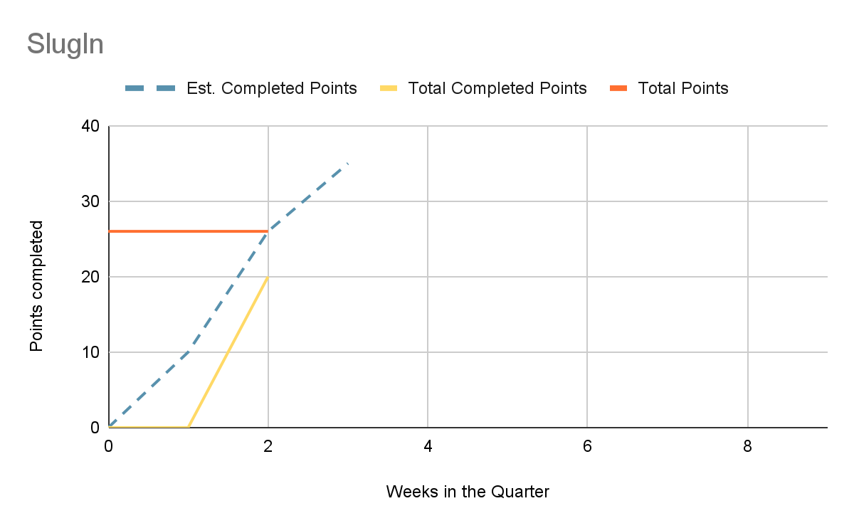
Initial scrum board: Also known as a task board, the scrum board is a physical board and labeled as such with sprint number and project name and located in the lab. This board has four columns, titled user stories, tasks not started, tasks in progress, and tasks completed. Index cards or post-it notes representing the user stories and the tasks for this sprint should be placed in the user stories, tasks not started, and tasks in progress columns. Tasks associated with a user story should be placed in the same row as the user story.

User Stories | Tasks not started | Tasks in progress | Tasks completed
  As a student, I want to make a profile so that I can look for opportunities and save them.
  As a student, I want to log in so that I can keep up with the applications I marked as applied for or saved.
  As a student, I want to see up-to-date opportunities by seeing out-of-date ones get taken down, so I save time applying to open ones.
  As a student, I want to see distinct categories (subject) so that I can easily navigate through all the opportunities on campus.
  As a student, I want to mark an opportunity as applied for once I have filled out the application linked to the opportunity or emailed the professor listed on the opportunity.
  As a student, I want to have new opportunities suggested to me based on the opportunities I have saved and applied for
  As a faculty member or student club, I want to make job postings and categorize the jobs (ex: psych) so that I can recruit new members.
  As a faculty member, I want to be able to see the number of saves and applications so I can see how well my posting is doing.
  As a faculty member or student club, I want to make a profile so that I can post opportunities.

Scrum times: List at least the three days and times during the week when your team will meet and conduct Scrum meetings. Also, indicate which of these meetings will have the TA/tutor visit as arranged with the TA/tutor. It is expected the TA/tutor will visit during the Scrum meeting during your lab time.

Times meeting:
- Saturday 1 pm - 2 pm
- Wednesday 9 am - 10 am
- Monday 9 am - 10 am
Meeting with TA:
- Wednesday 4:30 pm - 5:15 pm

User story | Task | In progress | complete | Story points
us1 | Task 1 | X - initials, date | X - initial, date
 | Task 2
 | Task n
us2

